**Day 76 Goals: what you will make by the end of the day**

No Data Science course can be complete without learning NumPy (**Numerical Python**). NumPy is a Python library that’s used in almost every field of science and engineering. It’s practically **THE** standard for working with numerical data in Python. The case studies for how NumPy is being used speak for themselves 😮

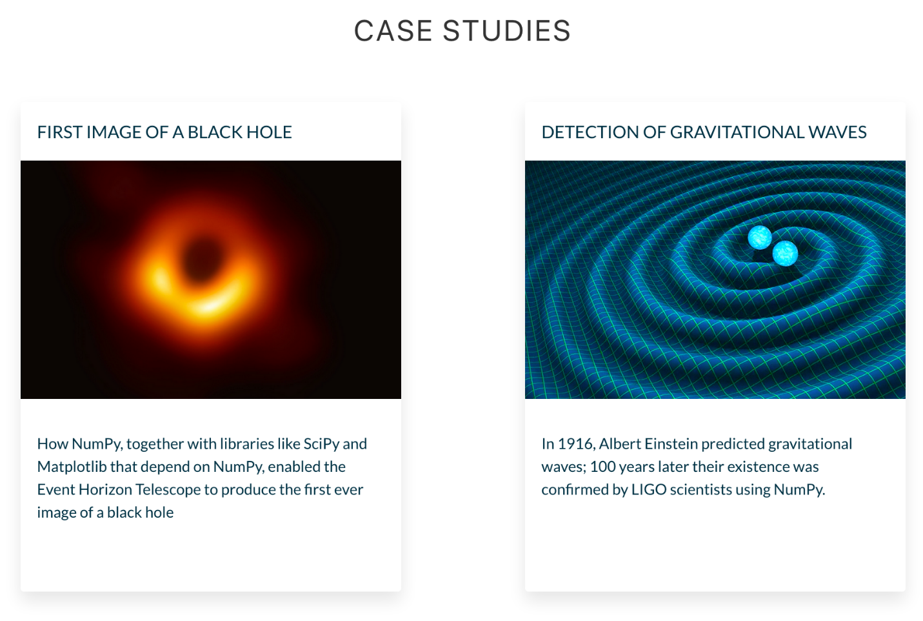

So far, we’ve been using Pandas, which is built on top of NumPy. Think of Pandas as a high-level data manipulation tool that includes functionality for working with time-series or for grouping, joining, merging and finding missing data (i.e., everything we’ve been doing so far). NumPy on the other hand shines with low-level tasks, like doing serious math and calculations.

**Today you'll learn:**

* How to leverage the power 💪 of NumPy's ndarrays.
* How to access individual values and subsets inside an n-dimensional array.
* How broadcasting 📣 works with ndarrays.
* How to do linear algebra with NumPy.
* How to generate points that you can plot on a chart.
* How to manipulate images as ndarrays.

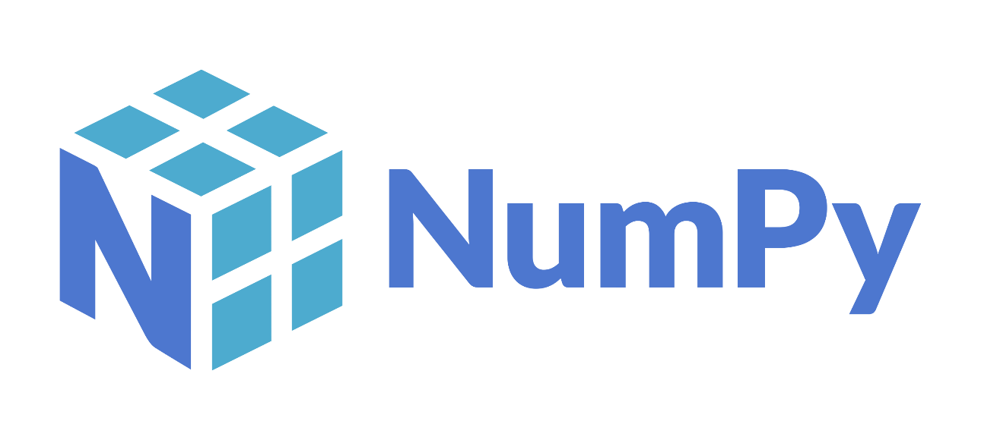

**Download and add the Notebook to Google Drive**

As usual, download the .zip file from this lesson and extract it. Add the .ipynb file into your Google Drive and open it as a Google Colaboratory notebook.

**Add the Data to the Notebook**

The .zip file also includes an image. This is the data for the project. Add this file to your notebook.